26 Gigabit smart POE switches

[Product Overview]
SY-24G2SP is 26 Gigabit Ethernet Power Switches (POE switches), high-quality network IC and the most stable POE chips, POE switches provide seamless connection to 10 / 100 / 1000 M Ethernet, and the POE supply port can automatically detect and supply receiving devices meeting IEEE802.3af or IEEE802.3at standards, non-POE devices intelligently detect no power and only transmit data.

POE technology (Power over Ethernet), Ethernet power supply technology, while also providing DC power supply technology for some IP-based terminals, such as IP phones, wireless access AP, network cameras, etc., DC receiving devices called powered devices.

With simple and convenient installation and maintenance means and rich business characteristics, we can help users to build a safe and reliable high-performance network. It is mainly located in the core or convergence layer of user networks of industrial parks, buildings, factories and mines, government organs, community broadband; and can be widely used in small and medium-sized enterprises, Internet cafes, hotels, schools and other Ethernet access scenarios.

[Main Features]
- Support for 24 Gigabit POE ports, + 2 Gigabit SFP optical ports
- Support for IEEE802.3, IEEE802.3u,IEEE802.3x,IEEE802.3ab,IEEE802.3z
- Compatible with IEEE802.3at (30W) and IEEE802.3af(15.4w)
- Ethernet ports support 10 / 100 / 1000M adaptive and POE features
- Support for port automatic flip (Auto MDI/MDIX)
- Exchange mechanism using storage and forwarding
- All ports support line-speed switching
- Zero configuration feature, automatically supplied to adaptive equipment
- Panel indicators monitor operating status and help with fault analysis
- Support for the 1-8-port QOS priority
- Three-gear one-key intelligent code dialing switch, supporting VLAN,Normal,Extend three modes
- Support port lightning protection Surge: common mode 4KV, differential mode 2KV; static ESD: air 8KV, contact 6KV

[Application Environment]
- Urban optical fiber broadband network: telecommunications, cable TV, network system integration, according to network operators
- Broadband special network: suitable for finance, government, oil, electricity, public security, education and other industries
- Multimedia transmission: image, voice, data comprehensive transmission, suitable for remote teaching, conference television, video telephone and other applications
- Real-time monitoring: real-time control of signal, image and data for simultaneous transmission

[Technical indicators]
I / O interface
Power supply input | AC100-240V/50-60Hz
Ethernet Network | 24* 10 / 100 / 1000Mbps PoE ports 2 * Gigabit SFP ports
Performance
Exchange capacity | 52Gbps
Package forwarding rate | 38.68Mpps
Package Cache | 4M
MAC Address Table | 8K
Giant frame | 9.6Kbytes
Forward mode | Storage forwarding
Standard
Network protocol | IEEE 802.3: Ethernet Media Access Control (MAC) protocol IEEE 802.3i:10BASE-T Ethernet  IEEE 802.3u:100BASE-TX Fast Ethernet IEEE 802.3ab:1000BASE-T Gigabit Ethernet  IEEE 802.3z:1000BASE-X Gigabit Ethernet (Optical Fiber) IEEE 802.3x: Flow Control
PoE Standard | IEEE802.3af(15.4W) IEEE802.3at (30W)
Industry Standards | EMI: FCC Part 15 CISPR (EN55032) class A EMS: EN61000-4-2 (ESD),  EN61000-4-4 (EFT), EN61000-4-5 (Surge)
Network media | 10Base-T: Cat3, 4, 5 Class or above UTP/STP (≤ 100m) 100Base-TX: Cat5 Class or above UTP/STP (≤ 100m) 1000Base-TX: Cat5 Class or above UTP/STP (≤ 100m) Multimode optical fiber: 50/125,62.5/125,100 / 140um Single-mode optical fiber: 8/125,8.7/125,9 / 125,10 / 125um
Certification
Safety Certification | CE, RoHS
Environmental Standards

Working environment | Operating temperature: -10~50 °C Storage temperature: -40~7 0 °C  Working humidity: 10%~90%, no condensation Storage humidity: 5%~90%, no condensation
Functional indication
Indicator lamp | PWR(Power indication), 1000M(chain street lamp), ACT (data lamp)
Status | PWR: Normally lit Equipment powered on / Unlit Equipment Unpowered 1000M: Bright Gigabit / not Gigabit or Link  ACT: always bright without data transmission / shiny data transmission / no link
Dial-Up Code Definition | Default:1-24 port standard exchange, free communication for all ports  VLAN:1-24 ports are isolated from each other and communicate with two optical ports Extend:17-24 port 10M mode, link extended to 250 m
Physical specifications
Structural dimensions | Product Size: 440 * 204 * 44mm Package Dimensions: 500 * 290 * 85mm Product net Weight: 2.82KG  Product gross weight: 3.38KG
Boacking Information | Outer box dimensions: 520 * 445 * 310mm Quantity of quantity: 5 PCS  Boacking weight: 17.5KG
Supply voltage | Input voltage: AC100-240V/50-60Hz Power supply power: 52V/5.76A
Boacking List | Switch: 1, manual: 1, certificate: 1, power cord: 1,1 pair of hanging ears
Order Information
SY-24G2SP | 26 Gigabit smart POE switches

[Product Effect]

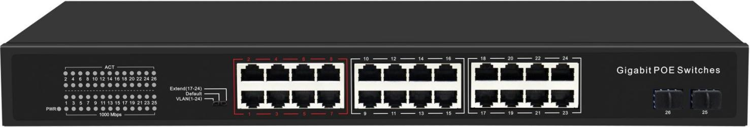

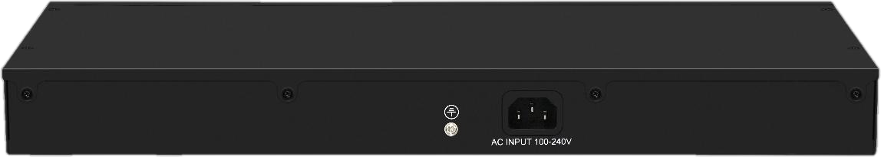

[ Product Application Chart]
