10 Port Gigabit Managed PoE Switch

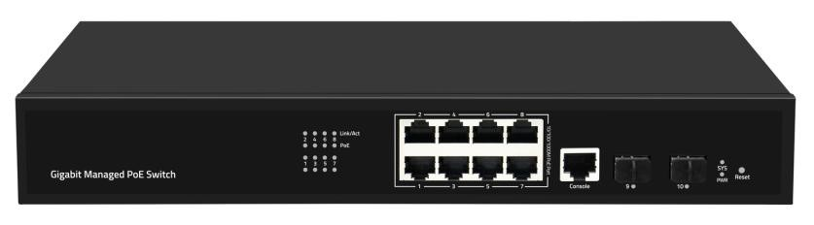

SY-8G2SMP is 10-Ports Gigabit Managed PoE Switch, it adopts high-quality and high-speed network IC and the most stable PoE Chip set, the PoE ports meet the IEEE802.3af/at standard, this series of PoE switches provides seamless connection to 10/100/1000M Ethernet,with automatically detective function on PoE port,power the devices with IEEE802.3af/at standard but only transmit data without forcibly power for Non-PoE devices.
PoE（Power over Ethernet）provides DC Power for IP-based terminals (such as IP telephones, wireless access AP, and network cameras) while transmitting data signals. The devices that receive DC Power are called Power receiving devices.

Main Features Application Environment

- 8*10/100/1000Mbps PoE Ports, 2*Gigabit SFP Uplink Ports, 1* Console Port
- Support IEEE802.3, IEEE802.3x,IEEE802.3u, IEEE802.3ab, IEEE802.3z standard
- Compatible with IEEE802.3at (30W) and IEEE802.3af (15.4w)
- Ethernet port supports 10/100/1000M adaptive
- Support PoE management, POE watchdog
- Panel indicator monitoring the status and help failure analysis
- Support 1U rack installation
- Support 802.1x port authentication, AAA authentication, support TACACS+authentication
- Support WEB, TELNET, CLI, SSH, SNMP, RMON management
- The ports support 6KV Surge Protection

Metro Optical Broadband Network:
Data network operators such as telecommunications, cable TV, and network system integration,etc.

Broadband private network:
Suitable for financial, government, oil, railway, electric power, public security, transportation, education and other industries

Multimedia transmission:
Integrated transmission of images, voice and data, suitable for remote teaching, conference TV, videophone and other applications

Real-time monitoring:
Simultaneous transmission of real-time control signals, images and data

Specifications
I/O Interface
Power | AC INPUT （100-240V）
Ethernet | 8 * 10/100/1000Mbps PoE Port 2* 1000Mbps SFP Port  1 * RJ45 Console Port
Performance
Capacity | 20Gbps
Packet Forwarding Rate | 14.88Mpps
Packet Buffer Memory | 4M
Flash Memory | 16MB
DDR SDRAM | 128MB
MAC Address | 8K
Jumbo Frame | 9.6Kbytes
Forwarding Mode | Storage & forward
MTBF | 100000 Hours
Standard
Network Protocol | IEEE802.3 (Ethernet MAC Protocol) IEEE802.3u (100BASE-TX Fast Ethernet)  IEEE 802.3ab (1000BASE-T Gigabit Ethernet)  IEEE 802.3z: 1000BASE-X Gigabit Ethernet (optical fiber) IEEE802.3x (Flow Control)  IEEE 802.3ad（LACP）  IEEE 802.1AB LLDP/LLDP-MED (Link Layer Discovery Protocol) IEEE 802.1D Spanning Tree Protocol (Spanning Tree Protocol) IEEE 802.1w Rapid Spanning Tree Protocol  IEEE 802.1s Multiple Spanning Tree Protocol IEEE 802.1Q （VLAN Bridge Operation）  IEEE 802.1p （VLAN Label）  IEEE 802.1X (Client/Server Access Control and Authentication Protocol)

PoE Protocol | IEEE802.3af （15.4W）  IEEE802.3at （30W）
Industry Standard | EMI: FCC Part 15 CISPR (EN55032) class A EMS: EN61000-4-2 (ESD)  EN61000-4-4 (EFT) EN61000-4-5 (Surge)
Network Medium | 10Base-T : Cat3, 4, 5 or above UTP/STP(≤100m) 100Base-TX : Cat5 or above UTP/STP(≤100m) 1000Base-TX : Cat5 or above UTP/STP(≤100m)
Fiber Medium | Multi-mode Fiber: 50/125, 62.5/125, 100/140um Single-mode Fiber: 8/125, 8.7/125, 9/125, 10/125um
Certification
Safety Certificate | CE, RoHS
Environment
Working Environment | Working Temperature：-10~50°C Storage Temperature：-40~70°C  Working Humidity ：10%~90%，non-condensing Storage Temperature：5%~90%，non-condensing
Physical Specification
Structure Size | Product Dimensions: 320*207*45mm Packing Dimensions: 366*312*71mm Product N.W: 1.65kg  Product G.W: 2.24kg
Packing Info | Carton Dimensions: 382*332*378mm Packing quantity: 5 sets  Packing weight: 12.2kg
Power Voltage | Input voltage: AC 100-240 V/50-60Hz Power supply: 52V2.88A 150W
Package List | Ethernet switch1 Set, Instruction manual 1 PCS, Certificate1 PCS, Power cord 1PCS Serial cable 1PCS, Brackets 1 pair

Function Indication
LED Indicators | PWR, SYS, PoE, Link/ACT
PWR (Power Indicator) | Lighting：Powered Un-Light：No Power
SYS (System Indicator) | Flashing: not start or fail Lighting: System Running
PoE (PoE Indicator) | Lighting：PoE on Un-Light：PoE off
Link/ACT (Link &Data Indicator) | Lighting: Link connection Flashing: Data transmission Un-Light: Link disconnect
Reset | Short press restart, long press 5 seconds to restore factory Settings

Software Function
Basic Function | Support hardware watchdog, factory reset, system and port LED
 | Support global information, statistical information, log information
 | Support User management, alarm management, configuration management
 | Support Port rate, duplex, flow control, max frame length configuration
 | Support Port mirroring, port speed limit, port energy saving
PoE Function | Support PoE time management
 | Support PoE automatic monitoring / PoE Watchdog
 | Support PoE port power configuration

Software Function
VLAN | Support 4K VLAN
 | Support 802.1Q VLAN, based on port VLAN
 | Support Access, Trunk, Hybrid VLAN mode
 | Support GVRP(Vlan registration protocol)
 | Support MAC VLAN, IP VLAN
 | Support Voice VLAN
MAC Address | Support MAC address automatic learning and aging
 | Support Static, dynamic, filtered address table
Security Features | Password protection
 | Support Restrict user access based on port number, IP address, MAC address
 | Support HTTPS, SSH V1/V2
 | Support VLAN-IP-MAC-PORT binding
 | Support ARP detection, IP source protection, DoS protection
 | Support DHCP Snooping、DHCP Attack protection
 | Support 802.1X certification
 | Support AAA (Authentication, Authorization, Accounting), Support RADIUS+
 | Support Port security, port isolation
Access Control | Support L2(Layer 2)～L4(Layer 4) Packet filtering function
 | Support Port mirroring, flow rate limiting, QoS remarking
QOS | Support 8 port queues
 | Support Port priority, 802.1P priority, DSCP priority
 | Support SP, WRR Priority scheduling algorithm
Spanning Tree | Support STP(IEEE 802.1d), RSTP(IEEE 802.1w) & MSTP(IEEE 802.1s) protocol
 | Support Multi-instance, Support Aggregate interface
 | Support BPDU Protection
Multicast | Support IGMP v1/v2/v3 Snooping
 | Support MLD v1/v2 Snooping

Multicast | Support Layer 2 multicast fast leave mechanism, querier
 | Support Layer 2 IPv4 static multicast
 | Support Layer 2 IPv6 static multicast
 | Support IGMP v1/v2/v3 Layer 3 multicast
Storm Suppression | Support multicast suppression
 | Support broadcast storm suppression
 | Support unknown uni-cast suppression
Ring Protection | Support Ring protection
Link Aggregation | Support Static Aggregation
 | Support LACP Dynamic Aggregation
 | Support based on IP, MAC, mixed load-balancing modes
 | Maximum support 8 aggregation groups (8 ports per aggregation group)
IPv6 | Support IPv6 Ping、IPv6 Traceroute、IPv6 Telnet
 | Support IPv6 SSH
 | Support IPv6 HTTP, IPv6 HTTPS
Management & Maintenance | Support WEB Management（HTTP, HTTPS）
 | Support CLI (Telnet, SSH V1/V2, Local serial port)
 | Support SNMP V1/V2/V3
 | Support RMON V2
 | Support LLDP Device discovery
 | Support SNTP Time synchronization
 | Support DNS Client
 | Support CPU Monitoring, Memory Monitoring
 | Support System log, classification warning
 | Support Ping, Traceroute detection, cable detection
Order Information
SY-8G2SMP | 10 Port Gigabit Managed Ethernet PoE Switch

Picture

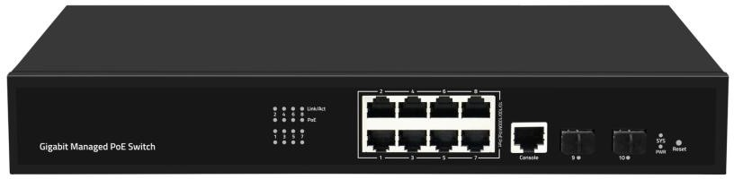

Product structure

